**This was a kind of a brainstorming document, the Rollie VR Pitch document is a much better explanation of the project as a whole.**

**Overarching Prompt:**

Inspired by the new body exhibit coming to Discovery World and the Google glasses, we’ve decided this project will be our take on a cheaper, easier to put together a set of smart glasses to be used with a virtual reality experience related to the body.

**Detailed Proposal:**

*Intro*

Using a modified Galactic Gladiator Helmet (from July KDI projects), we’ll use a set of focal lenses to complete the DIY google glasses. Below is a prototype of the “VR Galactic Gladiator Headset”:

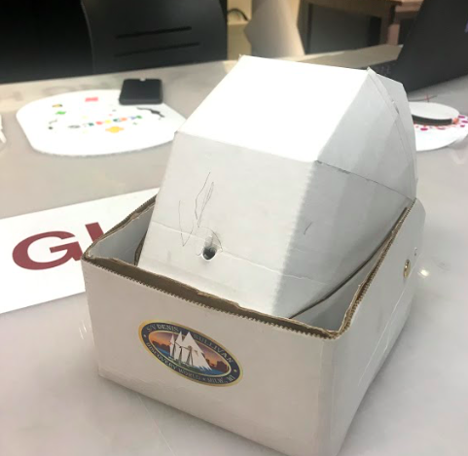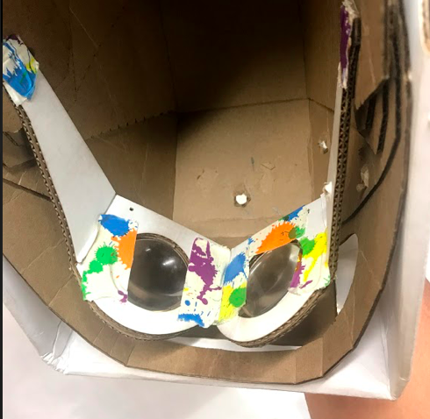

My senior design project at Marquette was a communication device for an eight year old girl with Emanuel Syndrome, which is a chromosomal disorder that disrupts normal development and different parts of the body (more info: <https://rarediseases.info.nih.gov/diseases/9835/emanuel-syndrome>). The project will create a virtual reality experience to (1) explain the scientific background of Emanuel Syndrome and (2) to make a realistic and interactive space to understand what it is like to experience the different symptoms of the syndrome. Then, a solution to one of the symptoms, inability to communicate, will be present to introduce the idea that biomedical engineers can develop solutions to everyday difficulties like the ones people with Emanuel Syndrome experience.

*Details of Emanuel Syndrome*

Typically, people have 46 chromosomes: 2 pairs of each chromosome 1-22. Individuals with Emanuel Syndrome have one extra chromosome, a combination of chromosome 11 and 22, which is called derivative 22 or der(22) shown below. This extra chromosome causes the delay in intellectual development delay and body anomalies.

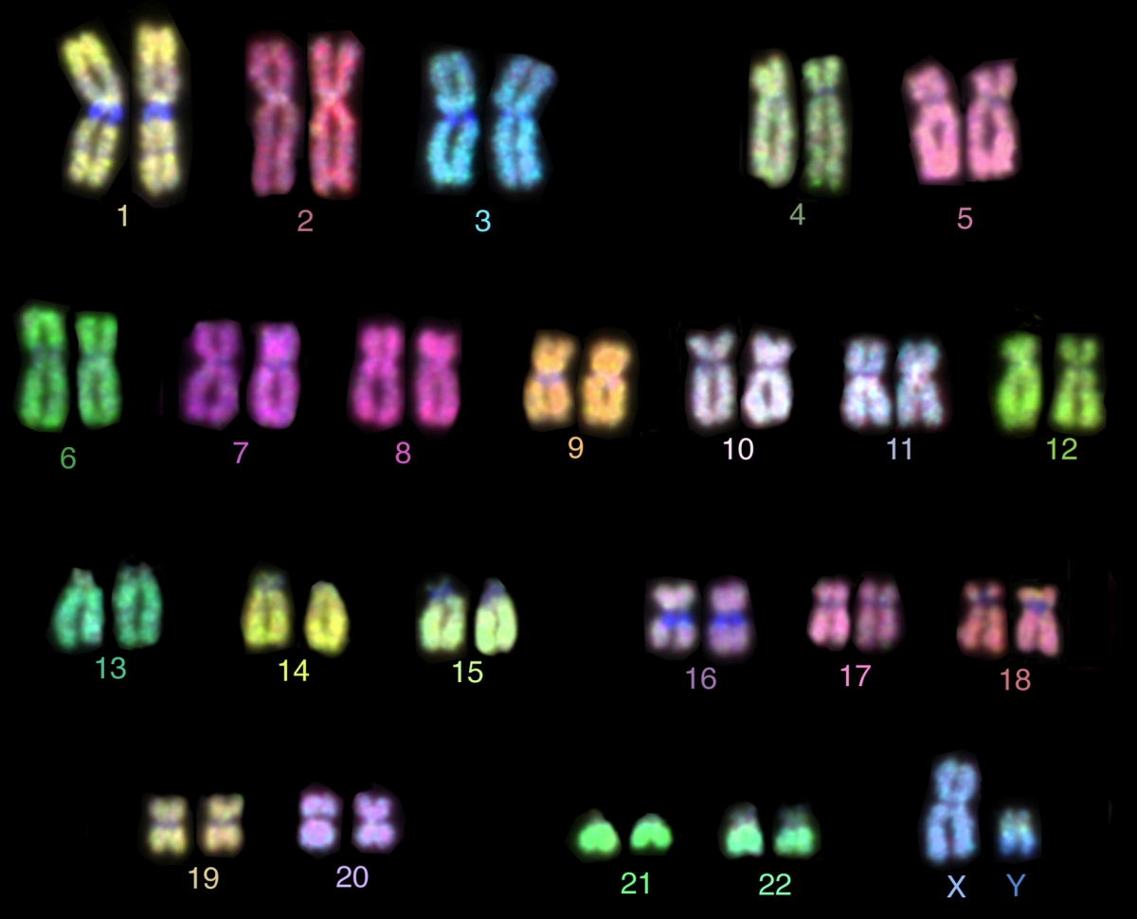

(XY = boy)

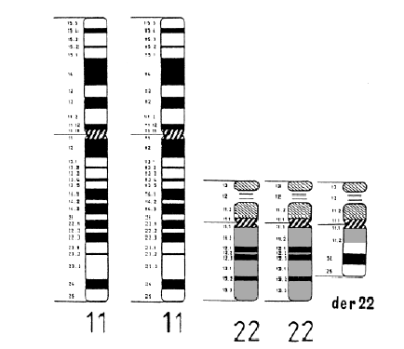

Extra chromosome in emanuel syndrome

The idea for this would be to go down the helix of the chromosomes and highlight 11 and 22. Then, the VR would show them melding together to become der(22).

*Symptoms*

**The following are the symptoms I noticed the client for my senior design team experienced. Research shows that symptoms are very unique to each person. However, since I am familiar with the client symptoms and have the contact information for her parents explaining her symptoms is best.

Idea: A day in the life of Olivia, living with her condition. Trying to communicate the toy she wants between two toys and not being able to.

|  |  |
| --- | --- |
| Symptoms | VR Experience |
| Spastic (head & hands) | How it looks when your spastic (visual impairments)  Create a sort of shaking view |
| Iris colomba (eye impairment)  <https://ghr.nlm.nih.gov/condition/coloboma> | A lense of the visual impairment  -at one point maybe couple this with a spastic head |
| Lack of fine motor skills | Do an everyday task  A hand reaching for something maybe and not doing what you want/expect it to |
| Cannot speak, just makes noises | Trying to communicate but no one can understand |
| Mental capacity of a toddler (but 8 years old) | **not really sure how to create this |

Idea: highlight the parts of the brain that are being activated during each of these symptoms

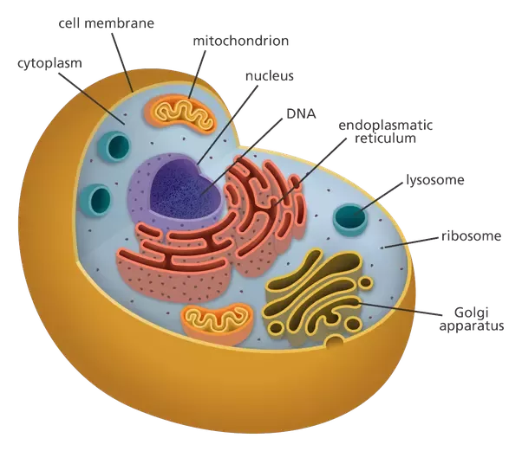

Chromosomes in the nucleus

